Assessment of Reservoir processes induced by geothermal utilization at Reykjanes, SW-Iceland, inferred from interferometric analysis of satellite images and gnss geodesy 2005-2019

Mylene Receveur1, Freysteinn Sigmundsson1, Michelle Parks2, Vincent Drouin1,3, Halldór Geirsson1, Sigrún Hreinsdóttir4, Ómar Sigurdsson5

1Nordic Volcanological Center, Institute of Earth Sciences, University of Iceland, Reykjavik, Iceland. Phone: (+33)637219017. E-mail: myr2@hi.is

2Icelandic Meteorological Office, Reykjavik, Iceland

3National Land Survey of Iceland, Akranes, Iceland

4GNS Science, Lower Hutt, New Zealand

5HS Orka, Grindavík, Iceland

**Abstract**

We study local deformation induced by geothermal utilization of the high-temperature Reykjanes system, SW-Iceland, since 2006 when a new 100 MWe power plant began operation. Using interferometric analyses of synthetic aperture radar (InSAR) images acquired by the Envisat, TerraSAR-X and Sentinel-1 satellites, time series of deformation have been determined for the 2005-2008, 2009-2016 and 2015-2017 time periods, respectively, complemented by Global Navigation and Satellite System (GNSS) data.

Surface displacements above the geothermal reservoir have been estimated from InSAR data at coherent pixels. Time-series of range change in the satellite line-of-sight (LOS) indicate a continuous deflation, with the highest rate observed for the 2005-2008 study period, where the main deformation area (about 4 km long by 2.5 km wide) is aligned along the Reykjanes fissure swarm, in the vicinity of the power plant. From 2009, the deformation zone narrowed to a 2-km wide circular subsidence bowl centered on the well field. Maps of approximate vertical and east displacement rates were inferred for each time period from the InSAR data. A total subsidence of about 285 mm together with horizontal contraction towards the centre of deflation of up to about 210 mm were calculated for the 2006-2017 period.

The average ascending and descending LOS velocities, derived at coherent pixels from each time series, are used to invert for the characteristics of the deformation source, modeling the reservoir as a body of simple geometry within an elastic half space. In the 2005–2008 period, the best fitting model is obtained for a near-horizontal ellipsoidal source at about 2.2 km depth, contracting at a rate of −7.3×105 m3yr−1. Modeling results for the periods 2009–2016 and 2015-2017 indicate a decrease in the rate of volume change down to −1.5×105 m3yr−1 and −0.9×105 m3yr−1, respectively, for a best-fitting point pressure source situated at about 1-km depth.

Similarities were found between the pattern of the decline in the modeled rate of volume change and the rate of pressure drop measured in observation wells at 1625 m.b.s.l., until the end of 2015. From 2015, minor pressure increase was however reported at that depth, while a continued pressure decline together with cooling were measured between 2009 and 2017 at 925 m b.s.l. Using production data as well as an analysis of the reservoir structure and of the rock properties, we find that the shallow deformation modeled since 2009 can be attributed to a combination of compaction under pressure decrease and thermal contraction of the rocks within or near a steam cap. This steam cap was formed in the topmost part of the reservoir (800–1200 m depth) in response to a sudden 3 MPa pressure drop associated to high rates of fluid extraction within the two-three first years of production.

The use of in-situ pressure/temperature measurements combined with ground deformation inferred from InSAR and GNSS observations provides valuable opportunities to monitor the detailed response of the Reykjanes reservoir to new production and reinjection strategies.

**Key words**: High-temperature geothermal reservoir, Radar interferometry; GNSS; Time-series analysis; Inverse theory; Modeling; Ground deformation

**Introduction**

* Studies of ground deformation induced by geothermal utilization from Interferometric Synthetic Aperture Radar (InSAR) images and GNSS data commonly used in Iceland (i.e. Krafla) and around the world
* Long-term monitoring at Reykjanes before the commissioning of new powerplant in 2006. Previous studies of deformation due to geothermal utilization in this region include : those undertaken by Keiding et al. (2010), Gunnarsson (2012), and Michalczewska et al. (2014). Keiding et al. (2010) analyzed C-band ERS and Envisat satellite data covering the period from 1992 to 2008 and GPS data from 2000 to 2009. Deflation over the Reykjanes geothermal area was attributed to pressure drop in the geothermal reservoir after the start of production for the 100 MWe power plant.
* Reykjanes is a high-temperature geothermal system located in SW-Iceland. NE/ENE graben structure controlled by two main faults channeling recharge from the SW. Composed of dyke complex, superimposed by basaltic lava and dolerite dykes… Extensive fracturing along dykes and temperature reaching XXX at the location of well RN-10. The volcanic systems in this region comprise central volcanoes with associated NESW trending fissure swarms and high temperature geothermal areas (Fig. 1). Transient electromagnetic (TEM) soundings indicate that the fumarole field at Reykjanes is underlain by a roughly circular low resistivity anomaly, with a radius of about 1.5 km at a depth of 800 m, transitioning into high resistivity at greater depth. This is interpreted to reflect the central part of the geothermal reservoir (e.g., Friðleifsson et al., 2014).

Figure 1

* Production initiated in 1976 but the highest between 2006 and 2009, reaching 800 kg/s and resulting in a 3 MPa pressure drop (increase in boiling conditions). Today, 15 wells producing the geothermal fluid at an average rate of XXX, including two shallow wells drilled in 2009 at 1225 and 960m to produce steam directly from the steam zone, and 5 reinjection wells. Decrease in rate of pressure drop = decrease in production rate, but different between the liquid- and steam-dominate zones.
* Summary of the results: determination of the deformation sources using inverse modeling and comparison of the results with pression and temperature changes and production rates. Linked to the geological structure to assess the poro-elastic and thermo-elastic processes, revealing the main contribution of the steam zone in the pattern of surface deformation in the vicinity of the Reykjanes power plant.
* Here we advance on previouswork by undertaking extended interferometric analysis of Envisat and TerraSAR-X data acquired between 2003 and 2016 to determine rates of displacement and provide constraints on the cumulative deformation fields caused by utilization. In addition we perform a probabilistic inversion to determine the optimal parameters for the source of the deformation.
* Update for the period 2017-2019 using sentinel-1 data and GNSS data.

**Methods**

***InSAR and GPS data analysis***

Synthetic Aperture Radar (SAR) images of Reykjanes from the period 2003-2019 have been utilized to study ground motion over the geothermal reservoir. InSAR analysis determines the phase shift between SAR images acquired from approximately the same location overhead but at different times (e.g. Liu et al. 2017). Interferograms are formed by comparing an initial “master” SAR image with a second “slave” image. As the satellite is “side-looking”, the relative displacement value of each pixel dLOS is recorded as phase change, representing range change in the LOS direction towards the satellite (Massonnet & Feigl 1998) proportional to the radar wavelength. In the absence of errors, it corresponds to the projection of the three-dimensional (3D) displacement field $\overline{d}=\left[d_{E},d_{N},d_{Up}\right]$ onto the unit vector $\overline{u}=\left[u_{E},u_{N},u_{Up}\right]$ pointing from the ground to the satellite:

$d_{LOS}=-\overline{d} • \overline{u}$ (1)

Ascending and descending interferograms covering the period 2003-2016 were formed from sets of images acquired over the study area by two different satellites (Parks et al., 2018). Data from the C-band ENVISAT satellite comprises 7 SAR images from the ascending track 173 and 24 SAR images from the descending track 138 covering the period 2003-2009. The X-band TSX satellite data comprises 59 SAR image from the ascending track 26 and 31 SAR images from descending track 110 spanning the period 2009-2016. From 2015, we used data from the C-band Sentinel-1 satellites, launched by the European Space Agency to monitor the evolution of the deformation over Reykjanes (Receveur et al., 2018). A total of XXX and XXX images from the C-band Sentinel-1 ascending track 16 and descending track 155, respectively, were used to generate a series of interferograms extending the initial time series until May 2019.

The DORIS software (Kampes and Usai, 1999) was used to process and form interferograms from the ENVISAT and TSX data. The STaMPS (Stanford Method for Persistent Scatterers) software (Hooper et al., 2007; Hooper et al., 2012) was then used to generate independent time-series of displacement in the satellite's LOS for each period covered by the InSAR data, and map the temporal evolution of deformation in the vicinity of the Reykjanes power (Parks et al., 2018). STaMPS uses a combination of the Persistent Scattered (PS) and Small Baseline (SB) approaches. The STaMPS PS method first involves the generation of single master interferograms, estimating the phase noise for each pixel and selecting PS pixels based on their noise characteristics. Second, the StaMPS SB method utilizes multiple master-slave interferograms that are selected to minimize both the temporal and perpendicular baselines (Berardino et al., 2002; Schmidt and Bürgmann, 2003), using single-look images to improve the identification of pixels with slowly-decorrelating filtered phase (Hooper, 2008). Both the PS and SB techniques identify a final subset of selected pixels from the input interferograms based on phase analysis. Sentinel-1 interferograms were formed using the (InSAR Scientific Computing Environment) software by processing the common bursts in the master and slave images overlapping the study area, together with the generation of coherence maps (Rosen et al. 2015). We evaluated the temporal evolution of the deformation over the period 2015-2019 by generating a time series of deformation for both ascending track T16 and descending track T155. The selected SAR images were co-registered to a single master image in each track, acquired on 20 August 2016 in T16 and 30 August 2016 in T155, chosen to minimize the temporal decorrelation (e.g. Maghsoudi et al. 2018). Average LOS velocity maps were generated over the Reykjanes area and displacement rates were determined pixel by pixel, using linear regression of the LOS displacement values within the whole time series of selected interferograms, using the approach from Drouin et al (2017). *In addition, we created time series of LOS displacements for the average phase value of a set of pixels situated in the area of highest deformation at Reykjanes. This approach was applied in order to reduce potential effects from individual pixels with significant noise.*

GPS data acquired from early 1992 were processed using the GAIT/GLOBK 10.6 software (Herring et al., 2010) using up to 100 global continuous stations to evaluate daily site positions in the ITRF08 reference frame (Parks et al., 2018). During the processing, satellite orbits and earth rotation parameters were determined and corrections for ocean loading were applied using the FES2004 model (Lyard et al., 2006). The IGS08 azimuth and elevation dependent phase center variation model was also applied for all antennas. The velocities were first projected into the ITRF08 Eurasian fixed reference frame and then corrected for plate spreading based on the MORVEL reference model (adding 9.3 mm/yr to the east component and subtracting 1.7 mm/yr from the north component) to establish site velocities in the reference frame of the plate boundary.

Components of the 3D deformation field in the area can be visualized by for all time periods forming a linear combination of the LOS velocities measured in the ascending and descending tracks $d_{ASC}$ and $d_{DES}$, respectively (Mickalczewska et al., 2014). The viewing geometries of the satellites dictate that the InSAR technique is not very sensitive to horizontal displacement in the north direction and that contribution of the east displacement component is approximately equal in value, but with opposite sign, in images acquired in ascending and descending geometries. By adding or subtracting them, and scaling the outcome considering the unit vectors for each track (eq. 1), an approximate estimate of the vertical (“near-vertical”) $n_{V}$ and the east component (“near-east”) $n_{E}$ of the displacement field can be derived (see e.g. Keiding *et al.* 2010).

***Geodetic modeling***

We inverted the average LOS displacement rates obtained from the time series analyses to estimate the parameters of a contracting source at depth that best replicates the observations. A set of models representing deformation sources embedded within a homogeneous, isotropic and uniform elastic half-space are considered. For the periods 2003-2009 and 2009-2016, a point pressure source (Mogi 1958) and an ellipsoid source (Yang et al., 1988) representing the geothermal reservoir were tested using a Poisson’s ratio $v=0.27$. For the period 2015-2019, we tested the Mogi source as well as a finite sized spherical pressure source (McTigue 1987), a planar horizontal rectangular and square sill with uniform closing (Okada 1985), and a horizontal penny shaped crack (Fialko *et al.* 2001), with a Poisson’s ratio $v=0.25$. Those models are assumed to correspond to a part of (the steam zone), or the total volume of the geothermal reservoir, causing the observed deformation. For each time period, the inversions were performed based on a Bayesian optimization approach.

**Results**

LOS deformation rate is calculated relative to a reference point at (-22.564°E; 63.814°N), which corresponds to the center of the selected reference area for the InSAR data situated to the east of the Reykjanes geothermal system. This point is situated near the STAD GPS station where a natural subsidence at a rate of about 6 mm/yr was measured before production began in 2006 (Hreinsdottir *et al.* 2001). Subsidence of this station has continued at a similar rate after the production began (Parks *et al.* 2018). Using this point as a reference, we reduce the contribution of other natural deformation signals compared to those induced by geothermal utilization.

During the initial years of production, the deformation signal at Reykjanes is characterized by an elongated elliptical shape trending in the NE-SW direction. From 2008, the velocity maps reveal a sub-circular LOS increase, with highest rates located in the center of the field. For the period 2005-2009, maximum LOS rates of -33 mm/yr and -28 mm/yr were obtained for ascending track 173 and descending track T138 were calculated relative to the reference point. For the period 2009-2016, maximum LOS velocities of -24 and -21 mm/yr were calculated for ascending track 26 and descending track 110, respectively (Parks et al., 2018). Finally, the analyses for the period 2015-2019 reveal a steady and linear trend over the study period, with an average maximum LOS rate of -23 mm/yr for both Sentinel-1 ascending and descending rates in the assumed zones of maximum deformation (Receveur et al., 2018; this study). Those results suggest a higher rate of displacement in the area of maximum change during the first 2–3 years of production, in accordance with GPS data (Parks et al., 2018).

The decomposition results are displayed in Fig. XXX. During the period 2005-2008, both the near-vertical and near-east displacements display an elongated elliptical shape trending in the NE-SW direction. A maximum value of -0.08 mm is reached by the near-vertical signal while the near-east signal displays maximum values of -0.07 m in the east to 0.07 m in the west, relative to the InSAR reference area situated to the east of the geothermal field. From 2008, the near-vertical velocity maps indicate a sub-circular subsidence bowl centered on the Reykjanes geothermal field. Maximum values of -0.19 mm and -25 mm/yr are reached in the area of maximum deformation located in the center of the deformation zone, for the periods 2008-2016 and 2015-2019, respectively. The near-east displacement, also more focused and in a circular shape, is characterized by a contraction towards the center of the zone of highest deformation. It reaches maximum values of −0.12 m in the east to 0.06 m in the west for the 2008-2016 period and of -10 to 5 mm/yr for the 2015-2019 period.

The parameters of the source responsible for the observed ground surface deformation since production started have been found by inversion of InSAR data using analytical models (Parks *et al.* 2018). These models assume that ground subsidence is the result of a pressure decrease in a body of simple geometry within a homogeneous and isotropic elastic half space representing the Earth. For the 2005-2008 period, the best fit was obtained for a near-horizontal ellipsoidal source at about 2.2 km depth displaying a rate of volume change of -7.3×105 m3/yr. In the period 2008-2016, both the point pressure source and ellipsoid provided a reasonable fit to the InSAR data. However, the Mogi point pressure source is the preferred one for this time period, due to the too large excess pressure required by the Yang model to fit the data, compared to the one observed in the wells during the same time period. Deformation modeling for this period indicated a decrease in the rate of volume change down to -1.5×105 m3/yr, for a best fitting point pressure source situated at about 1 km depth. This is in accordance with the independent modeling based on GPS data from 2008–2014 (Magnússon 2015, 2016). In addition, modeling of observed gravity changes corrected for estimated elevation changes, during the 2008-2010 period were interpreted in terms of mass renewal of the reservoir fluid in the range of 30-50%, representing a recharge rate of about 250 ± 60 kg/s (Magnússon 2009, 2013, 2015; Guðnason *et al.* 2015). The data were modeled considering mass-change in a spherical volume, with best fitting depth of about 1.3-1.7 km depth (Axelsson *et al.* 2015). Smaller yearly changes in micro-gravity after 2010 show greater renewal than up to 2010, indicating an increase in the rate of mass recharge to the system since production started (Gudnason *et al.* 2018).

The optimal source for the period covering the ENVISAT observations is a close to horizontal ellipsoid (plunge of 15°), situated at a depth of 2.2 km, with a semi-major axis of 5 km and aspect ratio of 0.2, corresponding to a volume change of −2.3 × 106 m3. The preferred source for the period spanning the TSX observations is a spherical type source situated at a depth of 1.2 km, with a volume change of −1.0 × 106 m3.

During the period covered by the Sentinel-1 data, the best fit is obtained for a penny shaped crack and contracting horizontal Okada layer.

The differences observed between the X, Y and depth locations of the source during these different time intervals suggests that the source migrated slightly SW and became shallower over time. This appears to be consistent with the shape of the LOS displacement, where the signal from ENVISAT is much broader than the TSX observations, suggesting a contraction of the source of observations. Comparison of our modeling results for the 2015-2017 period with the results from earlier periods (Parks *et al.* 2018) indicates a continued decrease in the rate of volume change since 2006 (Fig. 10). However, the decline in volume contraction in 2015-2017 relative to the period 2009-2016 is small, and contrasts with the sharp decline observed between the 2005-2008 and 2009-2017 periods. In addition, a similar depth of about 1 km was found for all the best fitting deformation sources obtained from inversion of InSAR data between 2009 and 2017, contrasting with the depth of 2.2 km inferred from the inversion of 2005-2008 data (Parks *et al.* 2018) and suggesting a migration of the deformation processes toward shallower depth.

**Deformation and physical processes**

Ground deformation above geothermal reservoirs is often attributed to poro-elastic or thermo-elastic processes, associated with pressure change or cooling of the reservoir rock. Change in specific volume, $v$, relates to change in pressure, *P*, and temperature, *T*, through the following equation:

$dv=\left(\frac{dv}{dT}\right)dT+\left(\frac{dv}{dP}\right)dP=vα_{v}dT-vcdP$ (4)

where $α_{v}$ is the volumetric coefficient of thermal expansion and *c* the total system compressibility of the fluid saturated material. The isothermal compressibility describes the change in a volume/thickness of rock due to a change in pressure under isothermal conditions. It is defined by a complex equation including the compressibility of the solid rock matrix and the compressibility of the pore fluid, which depends on the relative proportion of liquid water and steam phases (Grant & Sorey 1979; Brock 1986). Depending on the nature of the system (*i.e.* confined, unconfined, liquid-dominated, steam-dominated, two-phase system), the compressibility also controls the mass of fluid that can be stored or released per unit volume of rock under a unit pressure change, referred to as storativity (Axelsson 2012a).

The effects of temperature decrease are addressed in a modeling approach presented by Im et al. (2017). These authors argue that although the effects of pressure drop may be significant at the beginning of utilization, once pressure conditions reach a steady state later in the production, then the effects of temperature become dominant. This has been suggested to be the case at one of the main geothermal power plants, the longest in operation in Iceland, at Krafla volcano in North Iceland (Drouin et al., 2017). In a liquid-dominated system, the reduction of pore pressure $dP$ as a result of the depletion of fluid storage may lead to the compaction of water bearing deposits under increasing effective stress. Volumetric contraction can also be induced by cooling of the rock matrix under natural recharge or reinjection of cooler fluid as well as water vaporization, process requiring the transfer of heat energy from the rock to the fluid (*e.g.* Im *et al.* 2017, Ali *et al.* 2016). Thermal and poro-mechanical processes are however generally coupled in two-phase systems and can occur on various time scales that can be complex to separate. At Reykjanes, the migration of the modeled source of deformation from 2.2 to 1 km depth together with the change in both the subsidence pattern and the deformation rate since the end of 2008 clearly suggests an evolution of the responsible deformation mechanisms. We first consider in detail the effects of pressure changes, exploring as well possible change in material properties over time (i.e. compressibility), and then evaluate the effects of temperature changes. We infer the deformation at Reykjanes within our study period results from a combined action of pressure and temperature change within a steam zone.

Potential scenarios to explain the relationship between pressure, temperature and displacement rates: a nonlinear relationship between pressure drop and deformation, changing compressibility of the geothermal reservoir with time or thermal contraction, associated with minor cooling at a shallower level in the geothermal reservoir than the reference observation depth in the monitoring wells.

Drawdown and development of a steam zone in the uppermost part of the reservoir. First two options implied change in material properties associated with this process. Shallowing of the deformation source to ~1.2 km during 2009–2016 also suggests that the continued deformation observed on InSAR and GPS measurements during this period is related to processes occurring within the steam zone (above 1400 m). This could explain why continued deflation is observed, despite the apparent stable pressure during the later period, since the pressure is measured at a reference depth below this zone (1600 m). The wider deformation in the initial years of production shows that pressure drop influenced a wider volume, bracketed by the boundaries of the Reykjanes fissure swarm, which is elongated in the same manner as the displacement signal. In recent years, less crustal volume is responsible for the observed changes, eventually becoming consistent with shallower formation bedrock temperature change next to the utilized wells contributing to the signal.

The rate of pressure drop at 1625 m b.s.l. between 2009 and 2015 was lower than in 2006-2009, about -0.1 MPa/year in the center of the system and -0.07 MPa/yr at its periphery. A cumulative drawdown of -3.8 MPa was reached at this depth in 2015 relative to 2005 and between 2015 and 2017 a minor increase in pressure of 0.3 MPa was reported (Fig. 2). Not only has pressure declined in the liquid part of the reservoir, but also in the steam cap where relatively constant pressure decline at a rate up to -0.2 MPa/yr was measured at 925 m b.s.l. between the end of 2008 and 2017, resulting in an additional pressure drawdown of about 1.7 MPa when compared to the observations at 1625 m b.s.l.

In 2016, 13.5 Mt of geothermal fluid was extracted by 15 deep production wells and the two shallow dry steam wells RN-27 and RN-28 (Þorvaldsson & Arnaldsson 2017). Some of the deep wells are cased down to the bottom of the steam zone to produce from the liquid zone only and therefore generally display higher mass extraction rates (Ómar. Sigurðsson, HS-Orka, personal communication, 2018). The increase in steam fraction in the fluid produced by deep two-phase wells however contributed to a reduction in the yearly average mass production rate from 800 kg/s in 2008 to 430 kg/s in 2016 (Khodayar *et al.* 2016). In addition, reinjection of colder separated brine at 15 kg/s was initiated in July 2009 at about 2.5 km depth into well RN-20b to counterbalance the initial pressure drop (Flovenz *et al.* 2015). Until 2017, reinjection was performed at irregular rates into five wells, averaging to 80 kg/s over the whole time period with a maximum of 146 kg/s in 2016.

The pattern of the decline in the rate of volume change and the cumulative volume change appears to correlate well with the decrease in the rate of pressure drop measured at 1625 m b.s.l in the reservoir until end of 2015 (Fig. 2). Between 2015 and 2017, minor pressure increase is however reported at 1625 m b.s.l. in the liquid dominated part of the reservoir, while a continued pressure decline up to 1.7 MPa between 2009 and 2017 was measured at 925 m b.s.l. in the upper steam dominated part of the reservoir.

The NW-SE geological cross-section (Fig. 11) indicates that at the depth of the inferred deformation sources during the 2009-2017 period, the structure is dominated by rather fresh and porous breccias and pillow basalts only slightly compacted, with an average density ρ = 2500 kg/m3 (Hefu 2000; Friðleifsson *et al.* 2017). In addition, the center of the best fitting deformation sources is located in the 1-1.4 km depth range, which coincides with the inferred location of the steam-water boundary during the production period. The boiling zone in the initially liquid dominated reservoir would have expanded as a result of the pressure drawdown caused by the high production rates between 2006 and 2009, lowering the water table and resulting in the development of a 300-400 m thick steam zone (Appendix D). From 2008 and until summer 2016, feed zones located between 800 and 1200 m depth supplied wells with dry steam (Ómar Sigurðsson, HS-Orka, personal communication, 2017).

The 2.2 km deep ellipsoidal source estimated to be responsible for the deformation during the period 2005-2008 is located within a similar rock complex as the 2009-2017 deformation sources, but containing however, a greater density of dykes. The depth to its center moreover coincides with the location of the deep liquid-dominated aquifer.

## Relationship between volume and pressure changes

## Cooling of a horizontal layer

**Conclusion**

The hypothesis that the observed subsidence between April 2015 and October 2017 does originate from a shallow steam zone was suggested from the comparison of the inferred depth of the best fitting deformation source (1-1.4 km) with geological, temperature and pressure profiles, together with an analysis of the production history of the reservoir. The lateral extent of the modeled depressurized sources indicates that this steam cap covers a surface area of about 2 km², in accordance with the extent of the geothermal manifestation on surface (Palmason *et al*. 1985). Some residuals elongated in the NE-SW direction in the models however suggest that all the 2015-2017 deformation cannot be explained by the inferred shallow source and that NE-SW faults of the fissure swarm have some influence on the deformation field at Reykjanes. These residuals might be partly explained by the rectangular Okada source striking N46°E that offers a good fit to the data (Appendix B). Similar strike and elongation of the subsidence bowl was observed with InSAR at Reykjanes for the period 2005-2008 and best modeled by an ellipsoidal source at 2.2 km depth. We suggested that this initial deformation was due to the immediate compaction of basaltic rocks and dolerites in response to a large 3.0 MPa pressure drop in the central part of the reservoir in 2006-2009. Enhanced pressure diffusion along deep permeable NE-SW striking faults would have controlled compaction in the deepest part of the reservoir, along this direction.

The continued subsidence at lower rate since 2009 can partly be explained by compaction (i.e. reduction of the pore volume) within the inferred shallow steam zone, due to the continuation of pressure decrease at that depth. We also suggest the existence of a slow or delayed diffusion of the effect of this pressure decline, influenced by layers of lower permeability close to or within the inferred steam and boiling zones, where the pore fluid compressibility is higher. Thermal contraction can then be considered as a deformation mechanism taking over poro-elastic compaction (Mossop & Segall 1997), as observed at many systems when pressure equilibrium is reached after a few years of geothermal production (Im *et al*. 2017). Cooling in geothermal system can result from heat exchange between the host rock and colder recharge water. We thus consider combined temperature and pressure related processes linked to the two-phase nature of the geothermal system to explain the cooling of the rock observed in the steam and boiling zones (between 700-800 and 1200-1300 m depth).

Ground deformation at the Reykjanes geothermal area during the 2015-2017 period is well constrained by by interferometric analysis of Sentinel-1A and 1B radar images. LOS changes average to 16-20 mm/yr in the satellite LOS in the selected area of maximum deformation in both ascending and descending satellite tracks, with a maximum vertical displacement of about 25 mm/yr. When results from the two tracks are combined, the observations reveal a subsidence bowl centered on the well field together with a horizontal contraction toward the center of the deforming area. This subsidence can be fit with different sources of simple geometries, including a penny shaped crack model and a horizontal square layer, contracting at an average rate of (0.7-0.9)×105 m3/yr at about 1200 m depth. Models of deformation mechanisms reveal that the volume change during the 2015-2017 period can be explained by steam cap processes in the upper part of the geothermal reservoir, above 1200 m depth. These are characterized by a combination of a compaction of the estimated 400 m thick steam cap under a pressure decrease of 0.15 MPa/yr and by thermal contraction related to a 4-5°C/yr cooling of rocks within or close to the steam cap.

**Ackowledgment**

**FIGURES**



**Figure 1.** Geological maps. (a) Reykjanes Peninsula (Hjartarson & Saemundsson 2014), showing central volcanoes (red dashed lines) and the contours of the fissure swarms (orange dashed lines) after Johannesson & Saemundsson (1998), fault and fissures (black lines) and the direction of plate spreading (blue arrows) after Clifton & Schlische (2003). Inset shows the location of the map (black square) and the coverage of the Sentinel-1 ascending (T16) and descending (T155) tracks in Iceland. (b) Reykjanes geothermal system (after Saemundsson et al. 2010) showing the youngest lava flows and crater rows (red features) west of the area of high surface alteration (after Friðleifsson et al. 2018). (c) Map showing the location of drillholes (red and yellow circled crosses) and the ground surface traces of directionally drilled wells (black lines). Most of the wells are situated within the main upflow zone (red contour line) identified from resistivity surveys by Karlsd´ottir & Vilhj´almsson (2014), centred on the Gunnuhver thermal area, where the surface manifestation of hydrothermal activity is the highest. The NW–SE line indicates the location of the profile in Fig. 11. See legend for explanations of all symbols.

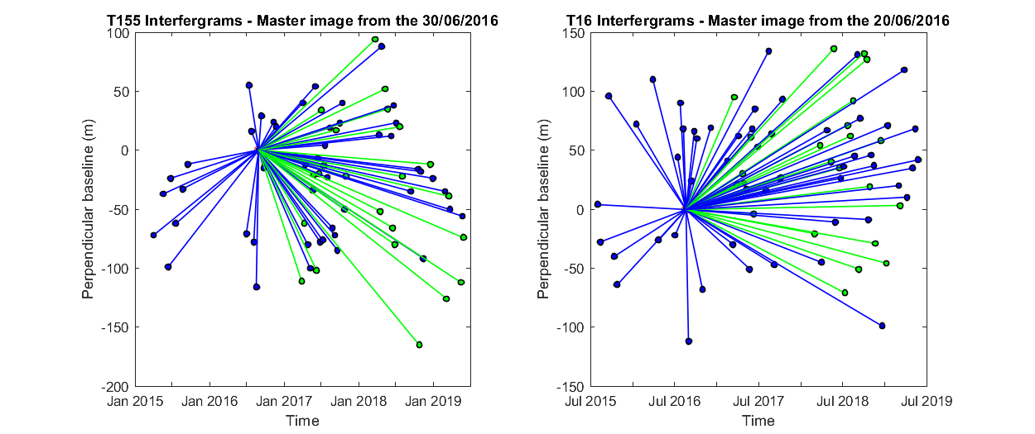

Figure 2. Star graphs showing the temporal and perpendicular baselines of the XXX interferograms of the T155 time-series (left-hand panel) and the XXX interferograms of the T16 time-series (right-hand panel) used in the time-series analysis and for the construction of the average velocity maps. Each dot corresponds to a single image from Sentinel-1A (in blue) and Sentinel-1B (in green) and each line represents an interferogram. The perpendicular baseline corresponds to the distance between the locations of the satellite at the two acquisition times, in the direction perpendicular to the satellite viewing direction. In deformation studies, minimizing the perpendicular baseline is important as it reduces the sensitivity of the interferometric signal to errors in digital elevation models used in the data processing. In Reykjanes, the maximum perpendicular baseline is XXX m for the 2016 August 20–XXX XXX XXX interferogram (Ascending Track 16).

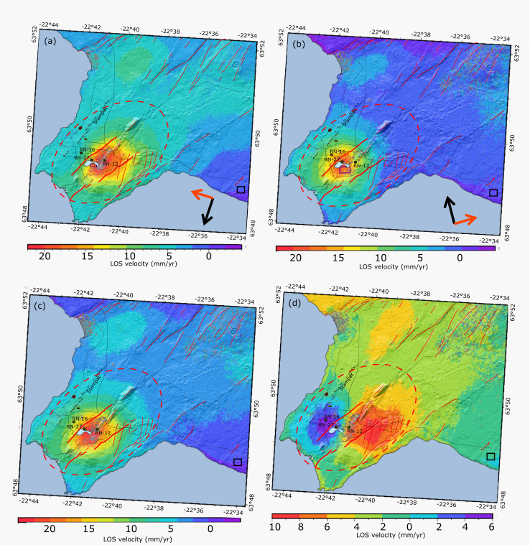

Figure 3. (a) LOS velocities for ascending Track 155 and (b) LOS velocities for descending Track 16. (c) Estimated near-vertical velocity component and (d) near-east horizontal velocity component; all shown in mm/yr. The grey colour indicates the areas with low coherence (<0.3). The black square corresponds to the reference area and the dark blue boxes in the area of high deformation in panels (a) and (b) correspond to the sampling areas for the estimation of the average LOS displacement rates (Fig. 4). These sampling areas, which corresponding to boxes of 200 m × 100 m and 400 m × 200 m in T16 and T155, contain 198 and 248 pixels with coherence >0.3, for T16 and T155, respectively. A broader area was defined for the T155 time-series due to the low coherence of the pixels in the zone of maximum deformation in this track. The red and blue lines represent the location of the profiles shown in Fig. 6. The red dashed circle indicates the location of the Reykjanes central volcano, the thin red lines represent the faults and fractures of the fissure swarm (Clifton & Schlische 2003) and the red bold lines correspond to the main Litla–Vatnsfell and Skalafell faults.

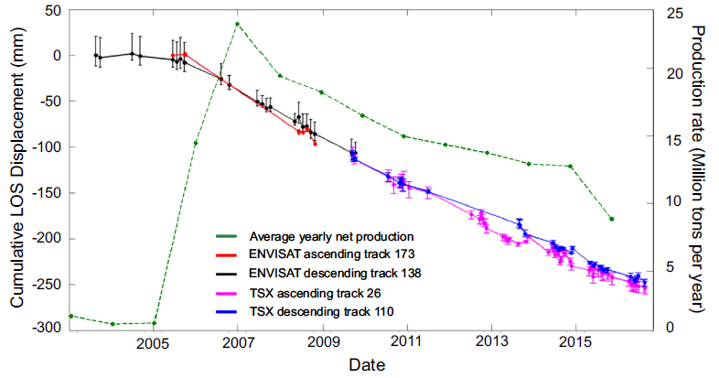 Time series of line-of-sight (LOS) displacement and average net production at Reykjanes. The displacement time series displays the difference between two reference areas. The circles display the average displacement for pixels within a 200 m radius of the maximum deformation area reference point. The error bars display the range of values within the same radius. The red dots represent the time series derived using data from ENVISAT ascending track 173, black from ENVISAT descending track 138, magenta from TSX ascending track 26 and blue from TSX descending track 110. The green dots represent the average yearly net production (extraction minus injection). Injection commenced in 2009.

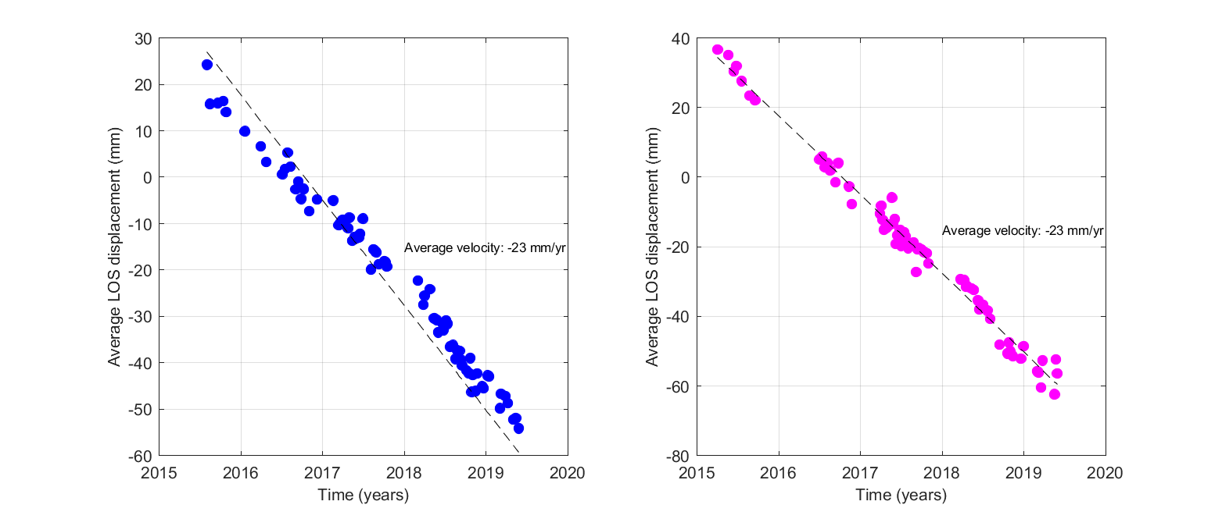

Figure 4. Time-series analysis of the average displacement of a set of points situated in the middle of the most deforming area, for pixels having a coherence higher than 0.3 in the selected interferograms. (a) Average LOS change of pixels within the area (−22.693◦E; −22.688◦E; 63.821◦N; 63.822◦N) for the ascending Track 16 relative to a master image acquired on the 20 August 2016. (b) Average LOS change of pixels within the area (−22.693◦E; −22.683◦E; 63.820◦N; 63.822◦N) for descending Track 155 relative to a master image acquired on the 30 August 2016.



Vertical displacements fromcontinuous GPS stations RVIT and SYRF, and campaign sites STAD, RNES, RN30 and S001, covering the period 1992 to 2017. The onset of production is marked by the red line and the M4.8 October 2013 earthquake by the blue line. (For interpretation of the references to colour in this figure legend, the reader is referred to the web version of this article.)

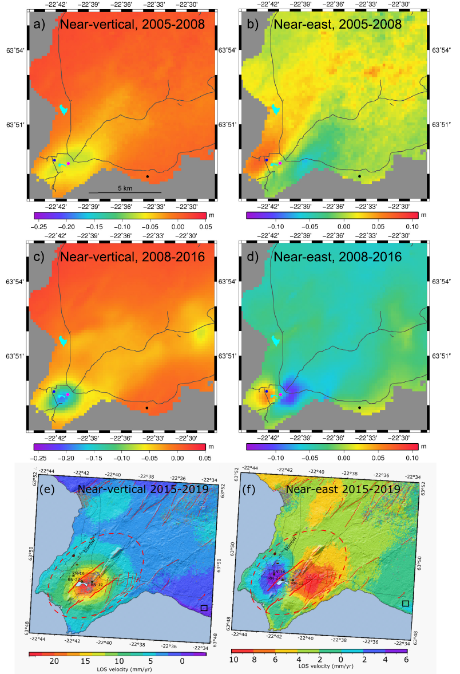

**REFERENCES**